OWN YOUR PERSONAL POWER - TOOLS!
In a post-COVID world, your stories, compelling vision, and superpowers (strengths vs. weaknesses) can be a source of fuel or disempower you from reaching your full leadership potential in life and business. Let’s get clear on what your current stories are, what your superpowers are, your compelling vision, and how to use them to create a roadmap and gateway to THRIVE, not merely survive.
- Tool #1: Own Your Story - What are the current stories you are carrying around?

Consider what you tell yourself and others about your life, business, clients, future, challenges, family, relationship?

- Does the narrative of your stories serve your life’s purpose and vision?

Do these stories empower you? If your answer is NO, if you were to use a renewed perspective, what could be a more empowering narrative for your stories?

- Tool #2: Today, what is a compelling vision for your business and life?

Imagine you and I are sitting down together 12 months from now. You had a wildly successful year. What happened? These are your goals. Consider: What impact did you have? (e.g., people, family, relationship, team, community, society, world)? Who did you serve? How many lives did you touch? How did you live your personal brand? What income level did you attain? What brought you tremendous joy? How did you enjoy your life? How did you feel throughout the weeks, month, and year?

What happened 12 months from now looking back… | Why is this goal important to you? | What can prevent you from attaining these goals if you don’t pay attention to it?
- Goal 1  - Goal 2, etc. | - Why is 1 important to you?  - Why is 2 important to you? | - Obstacle to attaining 1  - Obstacle for attaining 2, etc.

- Tool #3: Today, what are your superpowers/strengths?

List the thing that you know you are good at. Next to each, what can you do to become GREAT at them? This is how you develop your strengths instead of focusing on improving your weaknesses.

Things you are good at: | What can you do to become great at them?
- One  - Two  - Three | - One  - Two  - Three

- What activities do you spend time on that don’t serve your compelling vision (growth, higher income, wellness, family, etc.)?

What can you eliminate, automate, or delegate that you’re not great at or is not in your zone of genius? These are important aspects of your business and family life that you realize are a “weakness.” Consider every aspect of your business, e.g., sales, marketing, operations, product development, accounting, etc, and house management activities, e.g., cleaning, organizing, food shopping, etc.

LIST THE ACTIVITIES THAT YOU SPEND TIME ON | CHOOSE ONE OF THE FOLLOWING FOR EACH
 | AUTOMATE  ☐ | DELEGATE  ☐ | ELIMINATE  ☐
 | AUTOMATE  ☐ | DELEGATE  ☐ | ELIMINATE  ☐
 | AUTOMATE  ☐ | DELEGATE  ☐ | ELIMINATE  ☐
 | AUTOMATE  ☐ | DELEGATE  ☐ | ELIMINATE  ☐
 | AUTOMATE  ☐ | DELEGATE  ☐ | ELIMINATE  ☐
 | AUTOMATE  ☐ | DELEGATE  ☐ | ELIMINATE  ☐
 | AUTOMATE  ☐ | DELEGATE  ☐ | ELIMINATE  ☐
 | AUTOMATE  ☐ | DELEGATE  ☐ | ELIMINATE  ☐
 | AUTOMATE  ☐ | DELEGATE  ☐ | ELIMINATE  ☐
 | AUTOMATE  ☐ | DELEGATE  ☐ | ELIMINATE  ☐

- Tool #4 Roadmap: What are your key takeaways from this exercise? What are you committing to do over the next 12 months—this is your dynamic Massive Action Plan and roadmap. Copy/paste rows as needed.

DESIRED RESULT / OUTCOME / GOAL | PURPOSE, WHY IS THIS IMPORTANT? | ACTIONS & ACTIVITIES TO PURSUE IT | COMPLETION TIMEFRAME | OTHER RESOURCES

NOTES:

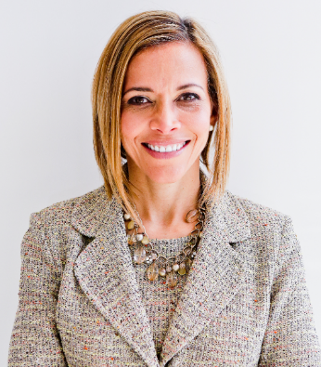  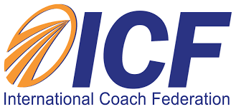  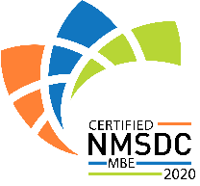 | ABOUT DR. GINNY A. BARO  Dr. Ginny Baro is an award-winning international transformational speaker & leadership coach, career strategist, and #1 bestselling author of Healing Leadership and Fearless Women at Work. Named one of the Top 100 Global Thought Leaders, Ginny is the CEO and founder of ExecutiveBound™ and Fearless Women @Work™and the creator of the Fearless Leadership Mastermind™. This virtual program is a new gold standard in leadership development that teaches women and leaders how to develop a competitive and unique edge and become more, inclusive, impactful, and influential leaders. Members deepen their confidence, emotional intelligence, and skills to add the most value and reach their full leadership potential in business and life. To learn more and save your virtual seat in the next cohort, please visit: www.FearlessLeadershipMastermind.com.  Ginny has successfully delivered leadership training and keynotes for Fortune 500 companies, impacting global audiences larger than 7,000. She holds a Ph.D. in Information Systems, an MS in Computer Science, an MBA in Management, and a BA in Computer Science and Economics. She's a Certified Professional Coach (CPC) accredited by the International Coach Federation (ICF). Born and raised in the Dominican Republic until the age of 14, she is fluent in Spanish. With her programs, she and her clients impact the lives of children and families in need through Feeding American, the Unstoppable Foundation, and other charitable organizations. For more information, visit www.ExecutiveBound.com.

